1. 
2. 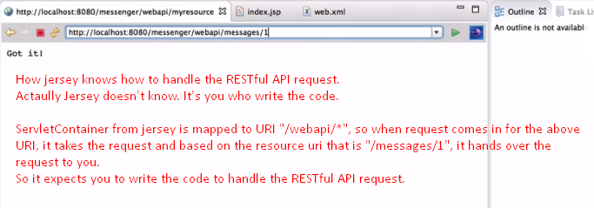
3. So, to handle a request for resource, what do you do?   
   You write Resource class.
4. 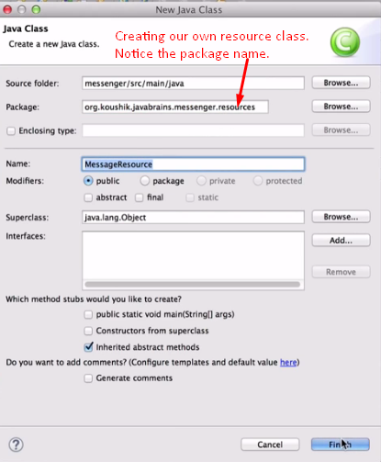 
5. 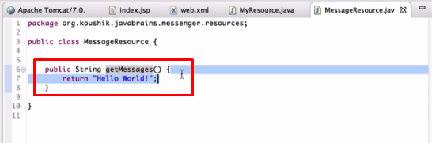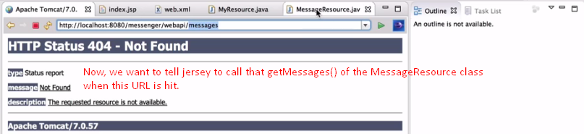  
   We also want to tell jersey to take the returned value from the method “getMessages()” and return that value as response for the above URL hit.
6. 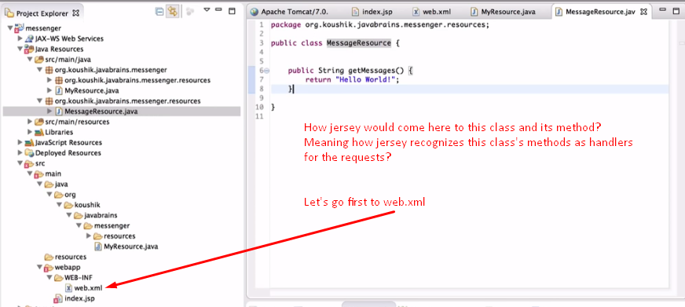
7. 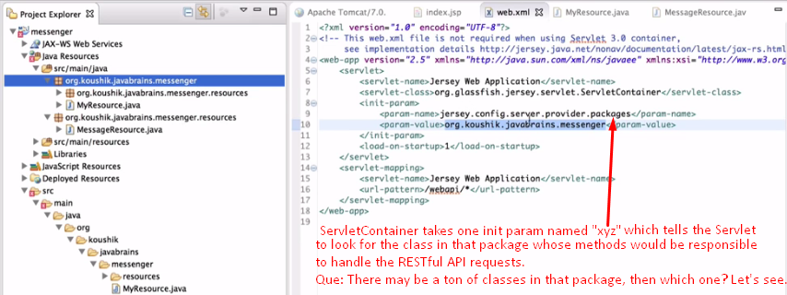
8. 
9. Yes, our class which would handle the REST API call is under the package passed as value to init param.
10. 
11. 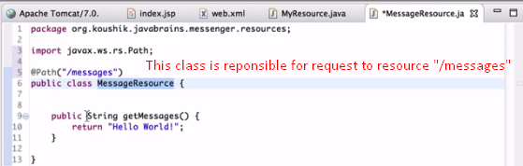
12. 
13. 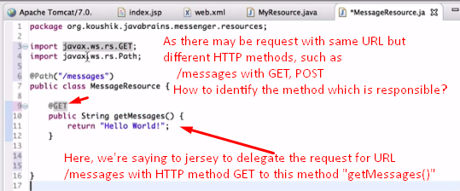
14. 
15. 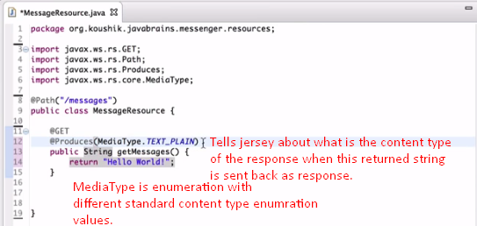
16. 